Game Design Document

Fill up the Following document

1. Write the title of your project.

Bubble Shooter

1. What is the goal of the game?

Shoot as many bubbles as possible

1. Write a brief story of your game?

The game launches bubbles of different colours. The shooter have to

shoot the balls, different colour balls have different score. The player,

who scores 500 points is the winner.

1. Which are the playing characters of this game?

* Playing characters are the ones which respond to the user based on the input from the user
* Cars, monkeys, dinos, wizards etc, are the playing characters in the game.

|  |  |  |
| --- | --- | --- |
| Number | Character Name | What can this character do? |
| 1 | Shooter 1 | Shoot Bubbles |
| 2 | Shooter 2 | Shoot Bubbles |
| 3 |  |  |
| 4 |  |  |
| 5 |  |  |
| 6 |  |  |
| 7 |  |  |
| 8 |  |  |

1. Which are the Non Playing Characters of this game?

* Non Playing characters are the ones which don't have an action or a behavior when the user interacts with the game.
* Hurdles, stones, bananas, coins, etc are non playing characters in the game.

|  |  |  |
| --- | --- | --- |
| Number | Character Name | What can this character do? |
| 1 | Balls | It falls randomly |
| 2 | Bullets | Shoots the bubbles on pressing arrow key |
| 3 |  |  |
| 4 |  |  |
| 5 |  |  |

1. Draw your imagination of this game. What does this game look like?

* Draw the game either on your computer or on paper,
* Add images of scenes of the game to show each of the playing and non-playing characters at least once.

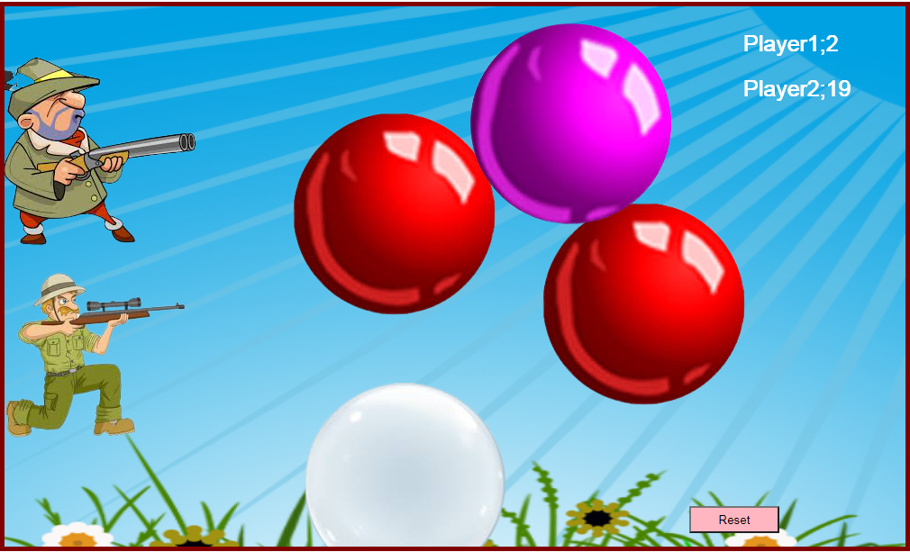

1. How do you plan to make your game engaging?

Bubbles will continue launching randomly until any one of the player scores

500 points, then Game Over window will appear and upon pressing reset

button, all values will be set to zero and the game will be ready to play

Again.